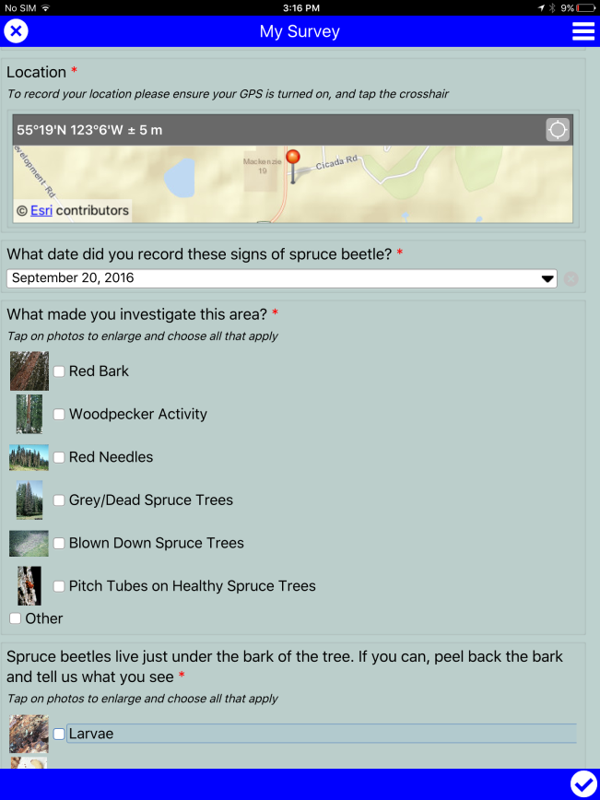
Spruce Beetle App

Spruce beetle occur naturally in the forests of BC. Usually, they are contained to blown down spruce trees. When conditions are favourable, populations can quickly grow and the beetles can successfully attack and kill standing healthy trees.

In order to safeguard ecosystem functions, values on the landscape, and midterm timber supply it is essential that we identify areas where the beetle populations are growing.

The Ministry of Forests, Lands and Natural Resource Operations is testing an app that will allow smartphone and iPad users to provide information on where/when they are coming across beetles in the forests.

To downloaded this App:
- Download “Survey123” from the App store
- Open “Survey123”
- Sign in with user – guestsbb and password guestsbb1
- Download the Spruce Beetle Survey
- When Complete go back a page (tap top left corner “<”)
- Tap on Spruce Beetle Icon

… once downloaded, you are ready to record and report on spruce beetle infestations.

Information collected on the beetle through this app will be used to focus further surveys and potential treatments.

For more information on the spruce beetles in this area, please call the Mackenzie Natural Resource Office: 250-997-2200

